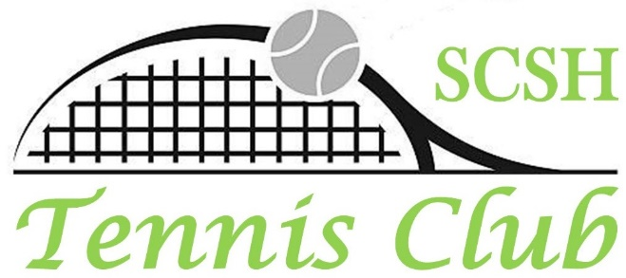
MEMBERSHIP FORM

January 2024 through December 2024

Tennis Club Web Site: https://scshtennis.com

Tennis Club membership dues are US $20.00 for the 12 month period of
January 1, 2024 through December 31, 2024, payable by January 1, 2024.
For new members, full dues are payable when submitting this form.
Please make check payable to SCSH Tennis Club, and put with this completed form and copy of your Informed Consent and Waiver in one envelope
and put in the Tennis Club Mailbox at the Montecito Clubhouse.
Please email our Tennis Club Treasurer, Barbara McDonald, when putting forms & payment
in the mailbox so she knows that it is there: baxtermom56@gmail.com

If you have any membership questions, contact Lori Brown, Membership Director @ s_brown1954@comcast.net, or 802-355-0402
Or Linda Johnson, Tennis Club President, @ lnkjohns@hotmail.com or 435-229-8655

Please Print All Information Clearly

Name: Date:

Tennis Rating & Type: (2.0, 2.5, 3.0, 3.5, 4.0, etc.): USTA – (must have a current NTRP computer rating, otherwise you are considered self-rated) Self Rated Non-player

SCSH Address:

SCSH Home phone:

Cell phone:

Email:

What is your SCSH residency status: _____ Homeowner _____Temporary Resident

(Temporary Resident is a renter or lessee with a Community Association membership or renter’s card)

A copy of your SIGNED Informed Consent and Waiver must accompany this form for Membership to be accepted. A link to Docusign to sign this waiver online can be found on our club website https:/scshtennis.com on the opening page under “How to Join the Tennis Club.

